Petty 2009 - Mass Media Attitude Change: Implications of the Elaboration Likelihood Model of Persuasion

* Book chapter covers how media influences can be seen through the ELM model
* ELM accounts for situations where people are \*not actively\* thinking about the message content.
  + Persuasion can occur when thinking is HIGH or LOW (very similar to system 1 and 2 thinking), but the processes and consequences of persuasion are different in each situation.
  + ELM states that processes that occur during the ‘yielding’ stage of influence can be seen as emphasizing one of two distinct ‘roads to persuasion’
* Central and Peripheral routes to persuasion
  + Central Route: Effortful cognitive activity whereby the person draws upon prior experience/knowledge, scrutinizes all information available, then determines the merits of the position
    - The individual is actively generating favorable/unfavorable (based on the directionality) thoughts in response to the persuasive communication.
    - NOT every message is sufficiently interesting or important to think about, and not every situation provides time/opportunity to carefully reflect.
    - Notably, provides evidence that individuals think different types of arguments are particularly persuasive (e.g., religious arguments and legalistic arguments can both be persuasive RE: capital punishment, based on the type of person). Individuals focus on what they consider important! (Cacioppo, Petty, & Sidera, 1982)
    - Increased media coverage increases accessibility for a given topic for individual people, choosing what to cover (vs. directly having an OPINION or POSITION on what is covered, can still be an impactful ‘indirect’ effect).
    - Once thoughts about the message are formed, these new thoughts integrate into the ‘overall cognitive structure’ – integration is more likely if the thoughts are held w/ high confidence.
      * Even though this requires ‘cognitive work’, the belief that is formed can very well be irrational or inaccurate.
      * The important point is that sometimes attitudes change based on a thoughtful process, involving assessment of information, which is directly ‘systematic’ thinking.
    - Attitudes derived from ‘central’ route have shared characteristics:
      * Easy to access from memory
      * Held with high confidence
      * Persistent over time
      * Predictive of behavior
      * Resistant to change (unless presented w/ outright contrary information)
  + Peripheral Route: When motivation or ability to process information is LOW, processes triggered by simple cues influences attitudes. It is NOT adaptive or possible for people to exert max mental effort at all times regarding all communications.
    - Features in the communication (e.g., pleasant scenery in a TV commercial) can elicit positive emotions (e.g., happiness), that are associated with the advocated position (as in simple classical conditioning!). The same can happen for the ‘source’ of a message, if it has a believable source, can trigger the ‘experts are correct’ heuristic
    - Can be very powerful in the short term – but as emotions pass, feelings change, and cues can stop being associated with the message.
    - Attitudes derived from ‘peripheral’ route have shared characteristics:
      * Less accessible
      * Less enduring
      * Not resistant to subsequent ‘attacking’ messages compared to ‘central’ persuasion.
  + “In sum, attitudes changed via the central route tend to be based on active thought processes resulting in a well-integrated cognitive structure, but attitudes changed via the peripheral route are based on more passive acceptance or rejection of simple cues and have a less well-articulated foundation”
* Variables affecting the amount of thinking
  + Some variables represent the level of ‘motivation’ to think about a message. E.g., a continuum ranging from those w/ high interest in a subject, to those who have no interest in a subject.
  + Perceived personal relevance of communication increases the level of ‘motivation’. For example, undergrads were told that at their own university [high relevance] or a distant university [low relevance] was planning to require all seniors to pas an exam in their major as a prerequisite to graduate – then the students listened to either strong or weak arguments in favor of the exam policy. As predicted by ELM, argument quality mattered a LOT more when it was about your own university vs a distant university (Petty & Cacioppo, 1979b).
    - E.g., As personal relevance increased, STRONG arguments were MORE persuasive, WEAK arguments were LESS persuasive.
    - Is it possible to hold a position w/ moral conviction and not have it be personally relevant? I think so ??(e.g., white person fighting for the rights of people of color).
  + More extreme attitudes were accompanied by a greater volume of polarized thoughts (e.g., strong arguments in high relevance = many favorable thoughts, weak arguments in high relevance = many unfavorable thoughts, as compared to low relevance).
  + Simply changing pronouns in a message from third person (e.g., “one” or “he and she”) to the second person (i.e., “you”) was sufficient to increase personal involvement and the processing of the message arguments (Burnkrant & Unnava 1989) self-relevant pronouns = strong arguments more persuasive, weak less persuasive, than if 3rd person pronouns were used.
  + Also, can increase self-relevance by framing a message to comport w/ the value or self-perception of an individual. If people think of themselves as not liking to think, then by framing the message as being for people who don’t like to think, thinking can be increased (Wheeler, Petty, & Bizer, 2005).
  + The source being perceived as high or low trustworthiness also directly impacts the extent of elaboration – sources of questionable trustworthiness engendered GREATER elaboration than sources perceived to be trustworthy (e.g., going to go to great lengths to poke holes in arguments of those that are sketchy)
    - This triggers mostly for people who generally have low need for cognition (Cacioppo & Petty, 1982), in those with high NFC, they did elaborated thinking regardless of source trustworthiness.
    - ELM states source trustworthiness influences thinking because people are motivated to hold ‘correct’ attitudes, and when a source is expert/trustworthy (e.g., likely to be ‘correct’), individuals can be reasonable confident of the attitudes by accepting the position advocated.
  + Higher elaboration also occurs when the message provider was seen as part of a stigmatized group (e.g., black or gay person). This source stigma is apparent only for people wo reject prejudicial beliefs (individuals low in prejudice may be motivated to pay particular attention to information from stigmatized sources) (Fleming, Petty, & White, 2005).
  + Elaboration also increases if the key arguments are presented as questions, instead of statements (Howard, 1990; Petty, Cacioppo, & Heesacker, 1981; Swasy & Munch, 1985). Thus, if an argument in a radio commercial was followed by a question (Isn’t this candidate the best one?) rather than by an assertion (This candidate is the best one), greater processing of the argument presented would result.
  + Elaboration can increase if there are multiple sources presenting an argument vs just one (however, this affect is attenuated if people think the multiple sources are NOT providing independent analysis of the issue).
* However… increased elaboration will only increase persuasion if the arguments in the communication are cogent and well reasoned, if the arguments are weak… The enhanced thinking will be detrimental to persuasion if the arguments are found to be specious.
  + Message processing speed/volume is limited – a complex/long message might require more than one exposure to adequately reach a high enough processing amount for the central route to be effective.
  + Repetition can be good and bad, depending!
    - Research shows clearly that moderate repetition of a message can be beneficial if arguments and cues are positive, but repeating the same message over and over eventually leads to boredom and reduced effectiveness. This “wearout” effect occurs regardless of whether the message is on a topic of high or low interest (Sawyer, 1981).
* Objective vs Biased thinking: Variables can also impact persuasion not just by increasing general motivation to think, but by influencing the KINDS of thoughts that come to mind
  + E.g., some features of persuasion increase the likelihood of favorable thoughts being elicited, vs unfavorable ones.
  + Obviously the most important one is whether the subject finds the argument presented cogent and strong.
  + Reactance can work however (telling them that they have no choice but to be persuaded on an important issue motivates counterarguing even when the arguments used are strong).
  + Attractiveness can affect biased thinking! “Under high thinking conditions, source attractiveness had no impact when attention was not drawn to it as a possibly biasing factor. However, when participants were told not to be biased by the attractiveness of the source, they actually showed more persuasion to the unattractive than the attractive source—a reverse bias brought on by their attempt to be unbiased”
* Persuasive Impact of Arguments Versus Peripheral Cues: A peripheral cue is a feature of the persuasion context that allows favorable or unfavorable attitude formation even in the absence of an effortful consideration of the true merits of the object or issue. Thus, just as source factors such as how expert or attractive the source is (Chaiken, 1980; Petty, Cacioppo, & Goldman, 1981; Petty, Cacioppo, & Schumann, 1983) can serve as a peripheral cue when motivation or ability to think are low, so too can the mere number of arguments in the message (Aaker & Maheswaran, 1997; Alba & Marmorstein, 1987; Petty & Cacioppo, 1984a) and the length of the arguments used (Wood, Kallgren, & Priesler, 1985; see Petty, Wheeler, & Bizer, 1999), since people can use the heuristic, “more is better.”
* Multiple Roles for Variables in the ELM
  + ELM states that any variable in the system can have an impact on persuasion by affecting the processes in the system in different situations.
  + E.g., the same feature of a persuasive message, can, depending on context, serve as an issue-relevant argument, a peripheral cue, or affect motivation/ability to think about the message (or bias thoughts, structural properties of thoughts, etc.)
  + When elaboration is high, a variable can serve as an argument if it is relevant to the merits of the issue.
    - When elaboration is LOW, evaluation is likely the result of simple association/inferences.
  + Individuals were also likely to interpret ambiguous information favorably if it comes from an expert vs nonexpert source.
* When motivation and ability are high, the # of items in a message are not counted as cues, but the information itself is processes for cogency.
  + Matching a message to characteristics of the recipient can influence attitudes by serving as a peripheral cue when elaboration is low, biasing thoughts when elaboration is high, and enhancing information processing at medium elaboration.
  + Emotion can biases thoughts by affecting how likely people think the consequences in the message are likely to occur. Positive outcomes are more likely, negative are less likely when in a state of happiness (vice versa for sadness).
    - Thus, positively framed arguments (e.g., if you stop smoking, you will live longer) are more effective when thoughtful people are in a happy rather than a sad state because people overestimate the likelihood of the positive consequence, but negatively framed arguments (if you don’t stop smoking, you’ll die sooner) are more effective in a sad than a happy state because thoughtful people overestimate the likelihood of the negative consequence (Wegener, Petty, & Klein, 1994).
* “First, the knowledge acquired could have been seen as irrelevant by the recipients, or might have led to unfavorable rather than favorable reactions. Second, even if favorable reactions were produced, people could have lacked confidence in those favorable thoughts, attenuating their reliance on them and reducing the likelihood of change. Third, even if appropriate attitude changes were induced, the changes might have been based on simple peripheral cues rather than on elaborative processing of the message. Thus, whatever changes were produced would be unlikely to persist over time and guide behavior. Fourth, even if attitude changes were produced by the central route, the people influenced could have lacked the necessary skills or self confidence to translate their new attitudes into action, or the impact of attitudes on behavior might have been undermined by competing norms. Fifth, even when people appear to have resisted the influence of mass media on traditional measures of persuasion, there might have been some potentially important yet previously hidden persuasive effects on alternative measures. For example, a media campaign might have failed to get people to develop more negative attitudes toward smoking on traditional deliberative measures, but automatic measures of evaluation might reveal that people have become more negative, or meta-cognitive measures might reveal that people have lost some confidence in their prior positive evaluation paving the way for future attitude and behavior change.
* Important elements
  + Although some attitudes are based on an effortful reasoning process in which externally provided information is related to oneself and integrated into a coherent belief structure (central route), other attitudes are formed as a result of relatively simple cues in the persuasion environment (peripheral route)
  + Any one variable (e.g., source expertise, mood) can be capable of inducing persuasion by either the central or the peripheral route in different situations by serving in one or more roles (i.e., affecting motivation or ability to think, biasing thinking, affecting thought confidence, serving as an argument, or a peripheral cue)
  + Although both central and peripheral route processes can lead to attitudes similar in their valence (how favorable or unfavorable they are), there are important consequences of the manner of attitude change such that more thoughtful attitude changes tend to be more consequential than less thoughtful ones.

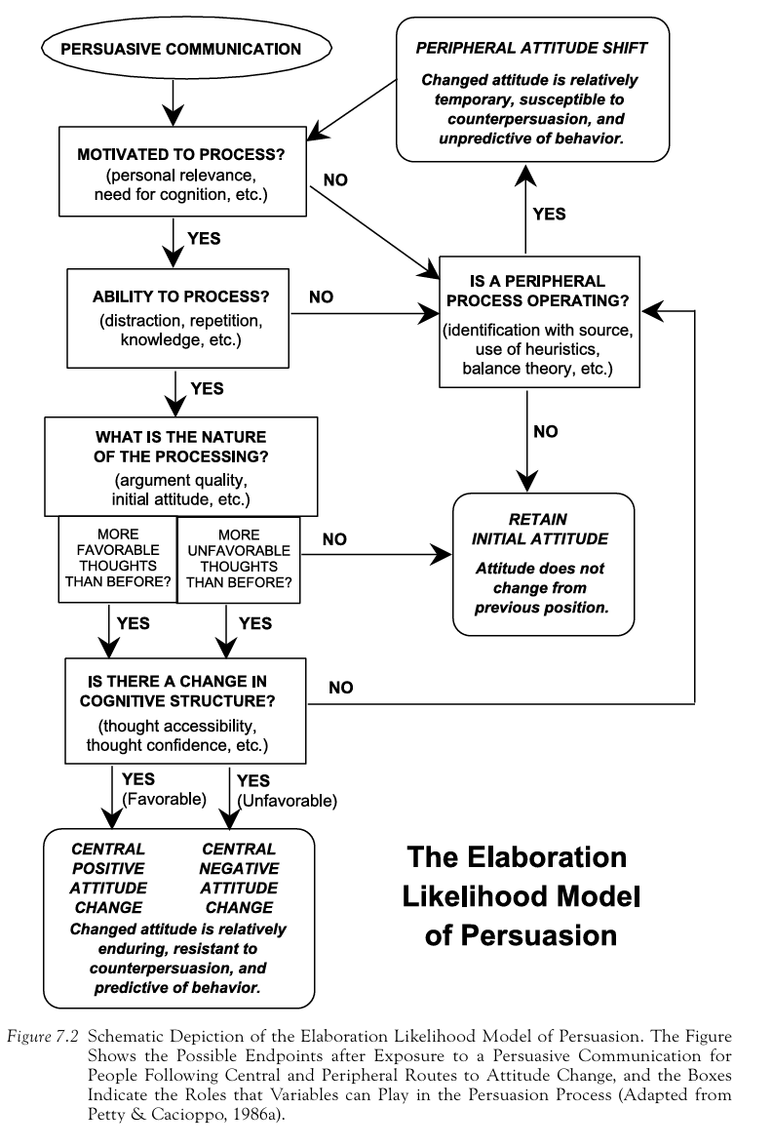

Kitchen 2014 – The Elaboration Likelihood Model: Review, Critique and Research Agenda

* ELM developed by Petty and Cacioppo (1981)
  + Persuasion was characterized beforehand by conceptual ambiguity/methodological differences.
* Describes the process of persuasion as either from extensive consideration of issue-relevant arguments, or the use of heuristic cues.
* Why is this model used so much?
  + Model is well constructed and clearly/simply articulates the process of persuasion.
  + The model is very descriptive, thus it can accommodate a broad variety of different outcomes
  + Model is VERY well cited – thus it’s inclusion is expected moving forward.
* ELM has great ‘post hoc’ explanatory power however, it’s unsure how good it is at predicting behavior, and the ELM was developed during ‘mass media’ market communication era (1980s).
  + Thus, it may result in thinking using this framework results in outdated ways of approaching an issue.
  + Notably, the digital landscape has drastically changed, thus the context in which the ELM was developed is not ‘as’ valid.
* Overview:
  + ELM provides an organizing framework applicable to various source/message/recipient/context variables.
  + Two routes to persuasion, central and peripheral, anchored at two opposite points on a continuum.
    - This continuum represents ‘cognitive effort’ expended to process a message.
    - Depending on a person’s motivation and ability, elaboration will be either high or low, which then results in the route of persuasion that may occur (central or peripheral).
  + Several variables mediate elaboration likelihood
  + ELM based on postulates:
    - Correctness Postulate: People want to hold ‘correct’ attitudes
    - Elaboration Continuum Postulate: Although people want to hold ‘correct’ attitudes, the amount/nature of issue relevant elaboration in which they are willing/able to do is based on individual/situational factors
    - Multiple-Roles Postulate: Variables can affect amount/direction of attitude change by; serving as persuasive arguments, peripheral cues, or affecting elaboration.
    - Objective-processing postulate: Variables affecting motivation/ability to process a message in an objective manner can increase or decrease argument scrutiny
    - Biased processing postulate: Variables affecting message processing in a biased manner can produce positive or negative motivation/ability bias to the thoughts.
    - Trade-off Postulate: As motivation decreases, peripheral cues become more important, as scrutiny increases, peripheral cues become less important.
    - Attitude-Strength Postulate: attitude changes from central route = greater persistence/predictivity/resistance to counter persuasion.
* Issues concerning ELM:
  + Model Assumptions/Descriptive Modeling
    - ELM makes assumptions without basis regarding what items are high/low involvement, which weakens their arguments.
    - ELM has a diverse/confusing literature base, because the model is inherently ‘descriptive’ rather than ‘proscriptive’.
      * E.g., the model does not specify a-priori, why exposure to many (vs few) arguments ought to motivate/enable objective processing, why prior knowledge ought to motivate/enable biased processing, or why source variables motivate objective processing w/ moderate elaboration.
    - ELM is hard to ‘falsify’ because each variable can hold multiple functions.
      * “a persuasive argument will be elaborated on under central route conditions is confounded because attitude change can potentially occur under other means. A lack of evidence of attitude change does NOT mean an absence of persuasion, but that this one form of persuasion failed under these specific circumstances” (O’Keefe, 1990; Stephenson et al., 2001; Cook et al., 2004)
* Continuum issues
  + The elaboration likelihood continuum has not undergone comprehensive empirical testing.
  + Specifically, that people have a default setting of ‘low elaboration’
  + If it’s a continuum, should have a smooth progression from high to low involvement, but instead, ELM is seen as clear delineation of motivation leading to specific types of behavior.
  + ELM also does not explain movement ‘along the continuum’
* Multi-channel processing
  + ELM is a dual-process model of change, however, how do these dual paths interact?
  + Individuals actually engage in ‘multi-channel’ processing of information, e.g., in certain contexts, peripheral cues may dominate, but both routes can work at the same time as well!
  + Mackenzie and colleagues (Mackenzie et al., 1986) posits a dual mediation model (DMM), wherein, central and peripheral routes are NOT mutually exclusive.
  + Kruglanski and Thompson’s Unimodel suggests people follow normative/heuristic rules to make judgements, as an alternative to the ELM. (Look back on our writing about the unimodel and how to integrate it w/ the ELM stuff?!?!?)
    - Unimodel draws from ‘classical’ conditioning, and also integrates ELM elements such as motivation and information processing capacity.
    - “the critical distinction between cues/and or heuristics on the one hand and message arguments on the other refers to informational contents relevant to a conclusion, rather than to principled difference in the persuasion process as such” (e.g., the whipped cream in a tub vs a can argument)
* Mediating Variables of the ELM
  + Affect, Involvement, and Cognitive Responses are some of the variables which mediate elaboration likelihood in the ELM.
  + Affect:
    - When elaboration likelihood is high one’s feelings may be central to the communication setting and thus subject to greater scrutiny (Bitner and Obermiller, 1985).
    - When individuals are unmotivated/unable to process, affect can serve as a peripheral cue, with mood serving as an informative heuristic w/ relatively little thought given (Petty et al., 2001, 2003)
    - Affect can directly impact BOTH the peripheral route (as seen above) but also the central route, as in circumstances of higher or greater motivation, affect can be seen as the ‘emotional core’ of the increased elaboration that leads to central route processing (Morris et al., 2005)!
  + Involvement: e.g., how much does this DIRECTLY affect me? The personal relevance to a communication setting.
    - As personal relevance increases, individuals are more likely to expend greater cognitive effort in evaluating relevant arguments (Petty and Cacioppo 1986) as well as engage in behavior consistent w/ their attitudes.
    - Response involvement: how the outcome of adopting a certain position will be immediately beneficial – large amounts of this decreases the amount of effort spent processing a message, caused by increased distraction/anxiety from the message receiver.
      * Contemporary term is ‘outcome relevant involvement’.
  + Leading individuals to ‘believe’ that they have elaborated extensively can ‘trick’ people into feeling as certain about a position as if they actually had elaborated extensively (Barden and Petty 2008)
  + Different levels of cognitive engagement mediate the argument strength-attitude relationship; strong arguments = greater positive response than those w/ weak arguments.
    - Additionally, argument quality and source credibility were strongly correlated (Stephenson et al. 2001)
* Replication of ELM: Most of the replications happened to cover either a small portion of the ELM or were done shortly after the development in the 80s.
  + All of them questioned the models validity – replications done on young children do not replicate. Arguably, this is because the original study was done on college students w/ high state levels of NFC and cognitive engagement.
  + ELM is also hard to replicate because argument quality can vary wildly amongst studies.
    - It’s hard to find a consistent measure of argument quality, which can lead to conflicting results (Areni and Lutz 1988).
* Summary/Conclusions
  + ELM has issues w/ descriptiveness, continuum, multi-channel processing, and mediating variables issues.
  + Has not replicated well

ELM High level overview